Figure 1. Concentration 40%, 60%,dan 80% Reflikasi 1
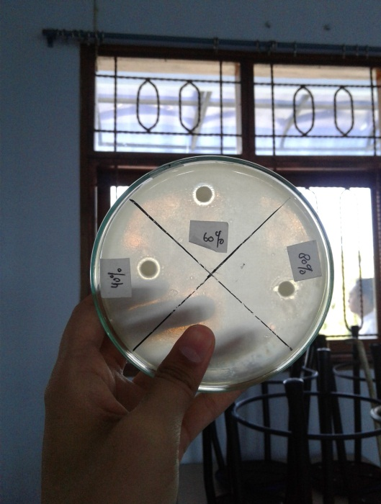

Figure 2. Concentration 40%, 60%,dan 80% Reflikasi 2
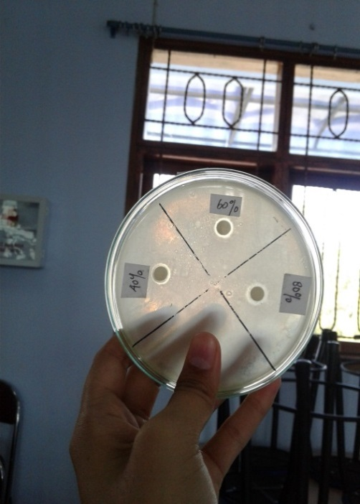

Figure 3. Concentration 40%, 60%,dan 80% Reflikasi 3

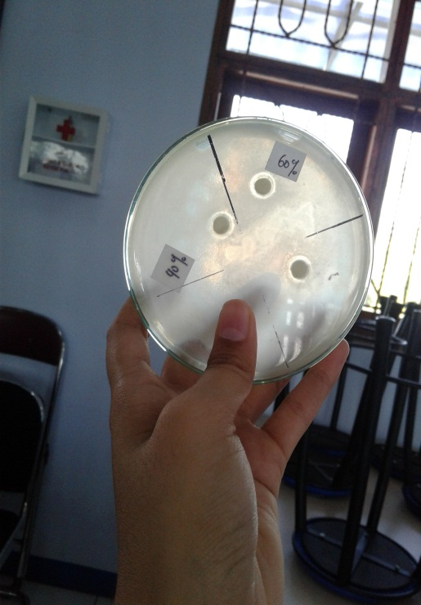
Figure 4. Positive Control Reflikasi 1,2,3

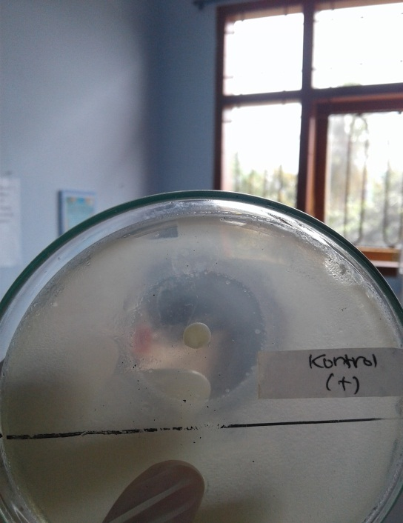  Positive Control Reflikasi 1 | 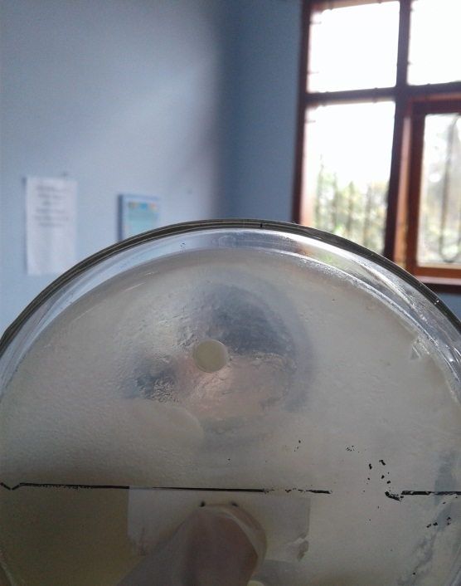  Positive Control Reflikasi 2

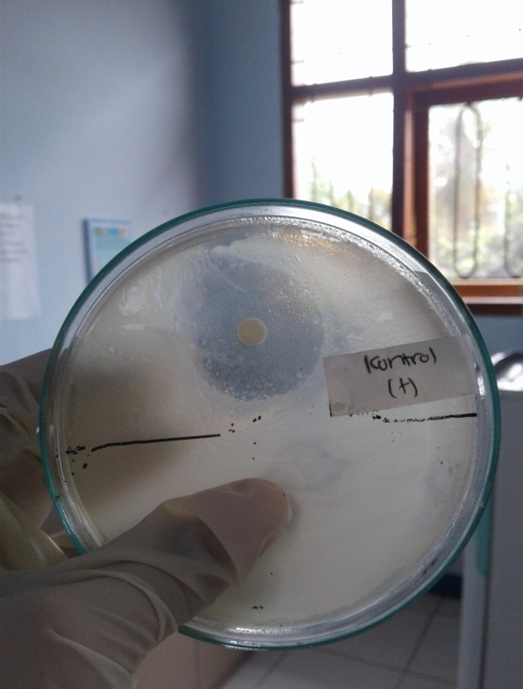
Positive Control Reflikasi 3

Figure 5. Negative Control Reflikasi 1,2,3

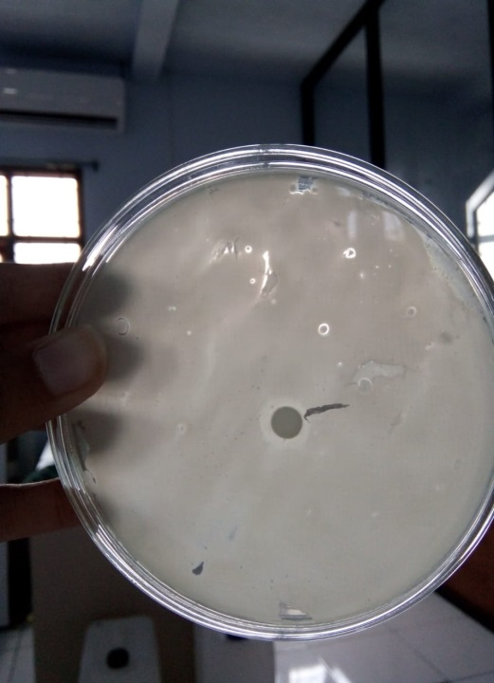  Negative Control Reflikasi 1 | 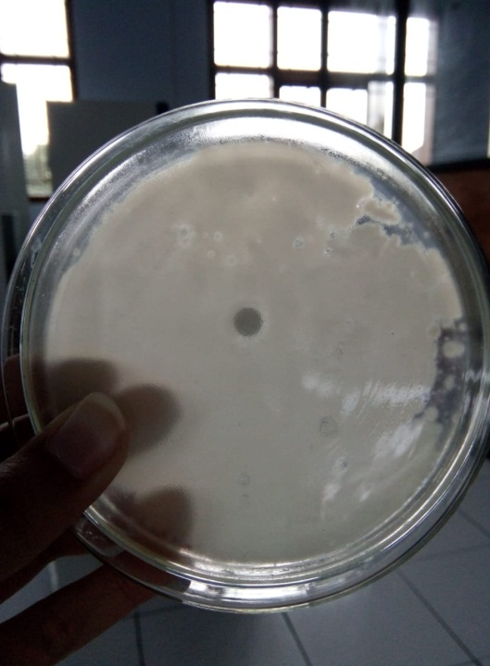  Negative Control Reflikasi 2

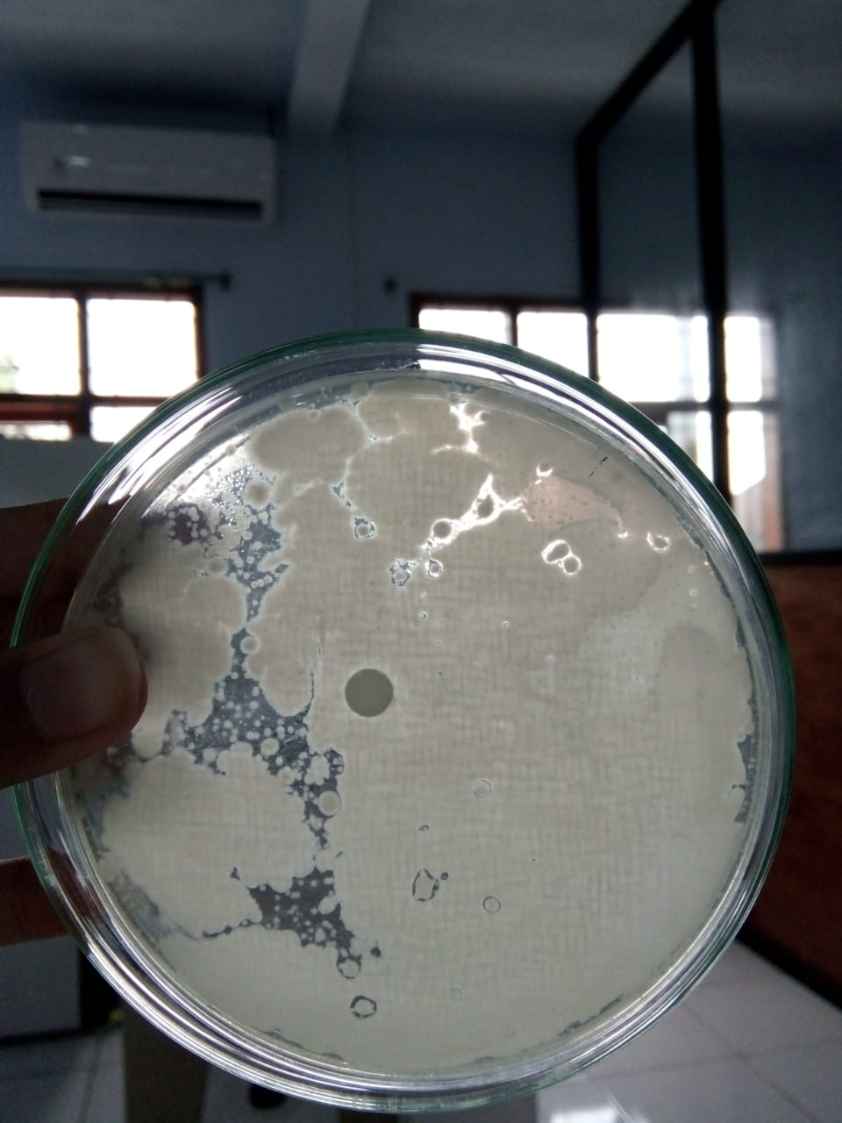
Negative Control Replikasi 3
Figure 6. Statistic Result
Statistics
luas daerah hambat
konsentrasi 40% | N | Valid | 3
konsentrasi 40% | N | Missing | 0
konsentrasi 40% | Std. Deviation |  | .000
konsentrasi 40% | Std. Error of Skewness |  | 1.225
konsentrasi 60% | N | Valid | 3
konsentrasi 60% | N | Missing | 0
konsentrasi 60% | Std. Deviation |  | .577
konsentrasi 60% | Std. Error of Skewness |  | 1.225
konsentrasi 60% | Skewness |  | -1.732
Konsentrasi 80% | N | Valid | 3
Konsentrasi 80% | N | Missing | 0
Konsentrasi 80% | Std. Deviation |  | 1.000
Konsentrasi 80% | Std. Error of Skewness |  | 1.225
Konsentrasi 80% | Skewness |  | .000
Kontrol (+) | N | Valid | 3
Kontrol (+) | N | Missing | 0
Kontrol (+) | Std. Deviation |  | 1.732
Kontrol (+) | Std. Error of Skewness |  | 1.225
Kontrol (+) | Skewness |  | 1.732
Kontrol (-) | N | Valid | 3
Kontrol (-) | N | Missing | 0
Kontrol (-) | Std. Deviation |  | .000
Kontrol (-) | Std. Error of Skewness |  | 1.225

Inhibitory area

konsentrasi uji |  |  | Frequency | Percent | Valid Percent | Cumulative Percent
konsentrasi 40% | Valid | 3 | 3 | 100.0 | 100.0 | 100.0
konsentrasi 60% | Valid | 3 | 1 | 33.3 | 33.3 | 33.3
konsentrasi 60% | Valid | 4 | 2 | 66.7 | 66.7 | 100.0
konsentrasi 60% | Valid | Total | 3 | 100.0 | 100.0
Konsentrasi 80% | Valid | 4 | 1 | 33.3 | 33.3 | 33.3
Konsentrasi 80% | Valid | 5 | 1 | 33.3 | 33.3 | 66.7
Konsentrasi 80% | Valid | 6 | 1 | 33.3 | 33.3 | 100.0
Konsentrasi 80% | Valid | Total | 3 | 100.0 | 100.0
Kontrol (+) | Valid | 24 | 2 | 66.7 | 66.7 | 66.7
Kontrol (+) | Valid | 27 | 1 | 33.3 | 33.3 | 100.0
Kontrol (+) | Valid | Total | 3 | 100.0 | 100.0
Kontrol (-) | Valid | 0 | 3 | 100.0 | 100.0 | 100.0

Histogram

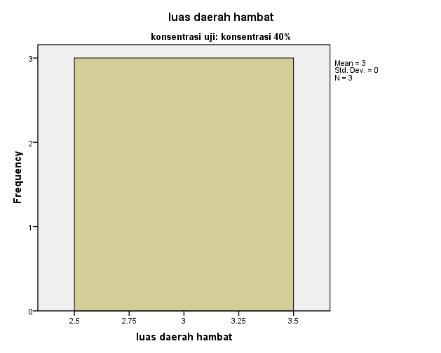
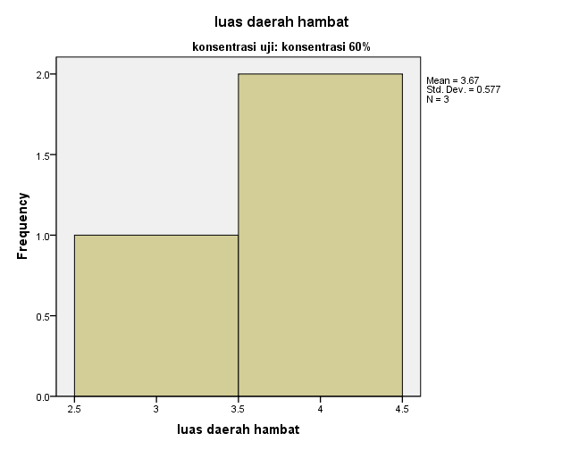
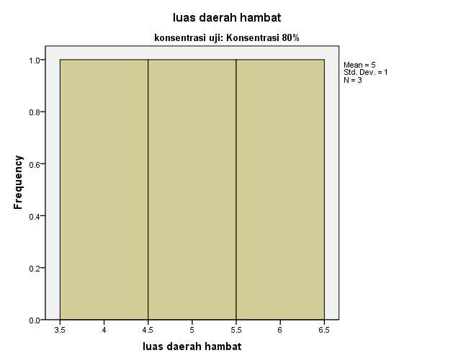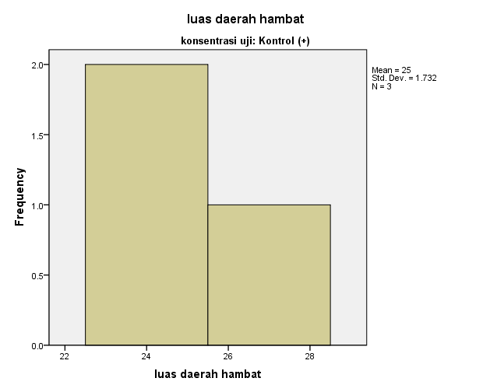
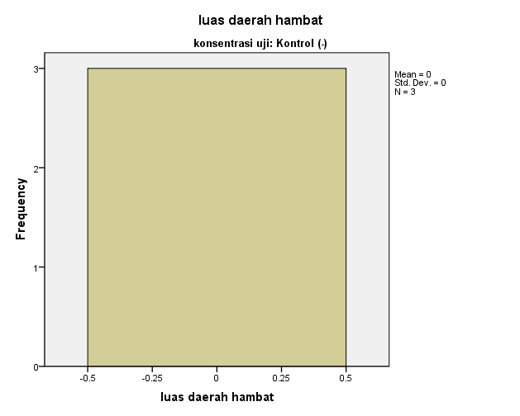

Oneway

Descriptives
abs_dif
 | N | Mean | Std. Deviation | Std. Error | 95% Confidence Interval for Mean |  | Minimum | Maximum
 |  |  |  |  | Lower Bound | Upper Bound | Minimum | Maximum
konsentrasi 40% | 3 | 2.5000 | .00000 | .00000 | 2.5000 | 2.5000 | 2.50 | 2.50
konsentrasi 60% | 3 | 4.1667 | 2.02073 | 1.16667 | -.8531 | 9.1864 | 1.83 | 5.33
Konsentrasi 80% | 3 | 5.6667 | 1.52753 | .88192 | 1.8721 | 9.4612 | 4.00 | 7.00
Kontrol (+) | 3 | 11.0000 | .86603 | .50000 | 8.8487 | 13.1513 | 10.00 | 11.50
Kontrol (-) | 3 | 2.0000 | .00000 | .00000 | 2.0000 | 2.0000 | 2.00 | 2.00
Total | 15 | 5.0667 | 3.49932 | .90352 | 3.1288 | 7.0045 | 1.83 | 11.50

Test of Homogeneity of Variances
abs_dif
Levene Statistic | df1 | df2 | Sig.
6.909 | 4 | 10 | .006

ANOVA
abs_dif
 | Sum of Squares | df | Mean Square | F | Sig.
Between Groups | 157.100 | 4 | 39.275 | 27.401 | .000
Within Groups | 14.333 | 10 | 1.433
Total | 171.433 | 14

Multiple Comparisons
Dependent Variable:abs_dif
 | (I) konsentrasi uji | (J) konsentrasi uji |  | Mean Difference (I-J) | Std. Error | Sig. | 95% Confidence Interval
 |  |  |  |  |  |  | Lower Bound | Upper Bound
LSD | konsentrasi 40% | dimension3 | konsentrasi 60% | -1.66667 | .97753 | .119 | -3.8447 | .5114
LSD | konsentrasi 40% | dimension3 | Konsentrasi 80% | -3.16667* | .97753 | .009 | -5.3447 | -.9886
LSD | konsentrasi 40% | dimension3 | Kontrol (+) | -8.50000* | .97753 | .000 | -10.6781 | -6.3219
LSD | konsentrasi 40% | dimension3 | Kontrol (-) | .50000 | .97753 | .620 | -1.6781 | 2.6781
LSD | konsentrasi 60% | dimension3 | konsentrasi 40% | 1.66667 | .97753 | .119 | -.5114 | 3.8447
LSD | konsentrasi 60% | dimension3 | Konsentrasi 80% | -1.50000 | .97753 | .156 | -3.6781 | .6781
LSD | konsentrasi 60% | dimension3 | Kontrol (+) | -6.83333* | .97753 | .000 | -9.0114 | -4.6553
LSD | konsentrasi 60% | dimension3 | Kontrol (-) | 2.16667 | .97753 | .051 | -.0114 | 4.3447
LSD | Konsentrasi 80% | dimension3 | konsentrasi 40% | 3.16667* | .97753 | .009 | .9886 | 5.3447
LSD | Konsentrasi 80% | dimension3 | konsentrasi 60% | 1.50000 | .97753 | .156 | -.6781 | 3.6781
LSD | Konsentrasi 80% | dimension3 | Kontrol (+) | -5.33333* | .97753 | .000 | -7.5114 | -3.1553
LSD | Konsentrasi 80% | dimension3 | Kontrol (-) | 3.66667* | .97753 | .004 | 1.4886 | 5.8447
LSD | Kontrol (+) | dimension3 | konsentrasi 40% | 8.50000* | .97753 | .000 | 6.3219 | 10.6781
LSD | Kontrol (+) | dimension3 | konsentrasi 60% | 6.83333* | .97753 | .000 | 4.6553 | 9.0114
LSD | Kontrol (+) | dimension3 | Konsentrasi 80% | 5.33333* | .97753 | .000 | 3.1553 | 7.5114
LSD | Kontrol (+) | dimension3 | Kontrol (-) | 9.00000* | .97753 | .000 | 6.8219 | 11.1781
LSD | Kontrol (-) | dimension3 | konsentrasi 40% | -.50000 | .97753 | .620 | -2.6781 | 1.6781
LSD | Kontrol (-) | dimension3 | konsentrasi 60% | -2.16667 | .97753 | .051 | -4.3447 | .0114
LSD | Kontrol (-) | dimension3 | Konsentrasi 80% | -3.66667* | .97753 | .004 | -5.8447 | -1.4886
LSD | Kontrol (-) | dimension3 | Kontrol (+) | -9.00000* | .97753 | .000 | -11.1781 | -6.8219
*. The mean difference is significant at the 0.05 level.

Homogeneous Subsets

abs_dif
 | konsentrasi uji | N | Subset for alpha = 0.05
 | konsentrasi uji | N | 1 | 2 | 3
Tukey Bª | Kontrol (-) | 3 | 2.0000
Tukey Bª | konsentrasi 40% | 3 | 2.5000
Tukey Bª | konsentrasi 60% | 3 | 4.1667 | 4.1667
Tukey Bª | Konsentrasi 80% | 3 |  | 5.6667
Tukey Bª | Kontrol (+) | 3 |  |  | 11.0000
Duncanª | Kontrol (-) | 3 | 2.0000
Duncanª | konsentrasi 40% | 3 | 2.5000
Duncanª | konsentrasi 60% | 3 | 4.1667 | 4.1667
Duncanª | Konsentrasi 80% | 3 |  | 5.6667
Duncanª | Kontrol (+) | 3 |  |  | 11.0000
Duncanª | Sig. |  | .060 | .156 | 1.000
Means for groups in homogeneous subsets are displayed.
a. Uses Harmonic Mean Sample Size = 3.000.

NPar Tests

Descriptive Statistics
 | N | Mean | Std. Deviation | Minimum | Maximum | Percentiles
 |  |  |  |  |  | 25th | 50th (Median) | 75th
luas daerah hambat | 15 | 7.33 | 9.332 | 0 | 27 | 3.00 | 4.00 | 6.00
konsentrasi uji | 15 | 3.00 | 1.464 | 1 | 5 | 2.00 | 3.00 | 4.00

Kruskal-Wallis Test

Ranks
 | konsentrasi uji | N | Mean Rank
luas daerah hambat | konsentrasi 40% | 3 | 5.50
luas daerah hambat | konsentrasi 60% | 3 | 7.83
luas daerah hambat | Konsentrasi 80% | 3 | 10.67
luas daerah hambat | Kontrol (+) | 3 | 14.00
luas daerah hambat | Kontrol (-) | 3 | 2.00
luas daerah hambat | Total | 15

Test Statistics^{a,b}
 | luas daerah hambat
Chi-square | 13.258
Df | 4
Asymp. Sig. | .010
a. Kruskal Wallis Test
b. Grouping Variable: konsentrasi uji

Uji Klomogorov Distribusi Normal
One-Sample Kolmogorov-Smirnov Test
 |  | Luas Daerah Hambat
N |  | 15
Normal Parameters^{a,b} | Mean | 7.33
Normal Parameters^{a,b} | Std. Deviation | 9.332
Most Extreme Differences | Absolute | .357
Most Extreme Differences | Positive | .357
Most Extreme Differences | Negative | -.216
Kolmogorov-Smirnov Z |  | 1.382
Asymp. Sig. (2-tailed) |  | .044
a. Test distribution is Normal.
b. Calculated from data.

